Lab: Adding more methods
Goal: show how we add extra methods to our endpoint

Add an inline data store for our pies
We’ll start off by moving our list of Pies outside of the GET methods we’ve created.
This allows us to reuse the same data for the entire controller.
Of course this is still a hard coded list; we’ll fix this later.
Steps:
- Add a new class called “PieStore” and add 3 methods
  - GetAll(), which returns all the pies
  - GetById(int id), which return the Pie with the provided Id
  - GetByPartialName(string name), which returns a Pie based on the name
public class PieStore
{
public static IEnumerable<Pie> GetAll()
{
return new List<Pie>
{
new Pie { Id = 1, Name = "Apple Pie", Description = "Tasty" },
new Pie { Id = 2, Name = "Cherry Pie", Description = "Yummy" },
new Pie { Id = 3, Name = "Pumpkin Pie", Description = "Delicious" }
};
}

public static Pie GetById(int id)
{
return GetAll().SingleOrDefault(p => p.Id == id);
}

public static Pie GetByPartialName(string name)
{
return GetAll().FirstOrDefault(p => p.Name.ToLowerInvariant()
.Contains(name.ToLowerInvariant()));
}
}
- Change our “GetPies” method, to use our “PieStore”
[HttpGet]
public JsonResult GetPies()
{
return new JsonResult(PieStore.GetAll());
}
- Launch the application (F5) and validate everything is still working when navigating to https://localhost:7043/pies

Add the GetById method
In this part, we’ll add another method to retrieve a single Pie, based on its Id value.
A common practice in API design, is to pass the Id as a route value:
e.g. http://localhost:7043/pies/1, where 1 is the Id.
Steps:
- Add a new method to our PieController called GetPie(int id)
[HttpGet]
public Pie GetPie(int id)
{
return PieStore.GetById(id);
}
- Launch the application (F5) and try to use navigate to the new endpoint:
  - https://localhost:7043/pies/1 Fails!
  - https://localhost:7043/pies?id=1 Fails!
- Try https://localhost:7043/pies (the one that was working before) Fails!
ASP.NET Core is unable to distinguish between the methods we just created.
To overcome this, we need to annotate our methods with the [Route] attribute.
- Add the Route attribute to the GetById method
Notice we’ve added a route template that expects an id placeholder “{id}”
[HttpGet]
[Route("{id}")]
public Pie GetPie(int id)
{
return PieStore.GetById(id);
}
- Let’s test the method by adding the call to our PieShopApi.http file
@PieShopApi_HostAddress = https://localhost:7043

GET {{PieShopApi_HostAddress}}/pies

###

GET {{PieShopApi_HostAddress}}/pies/1
- Launch the application (F5) and use the “Send request” button in the PieShopApi.http file and verify the result
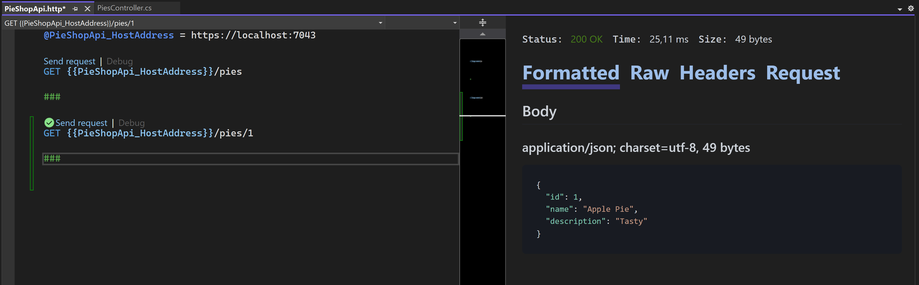
- Try to send a request to https://localhost:7043/pies/Apple
fails with HTTP status code 400-Bad Request
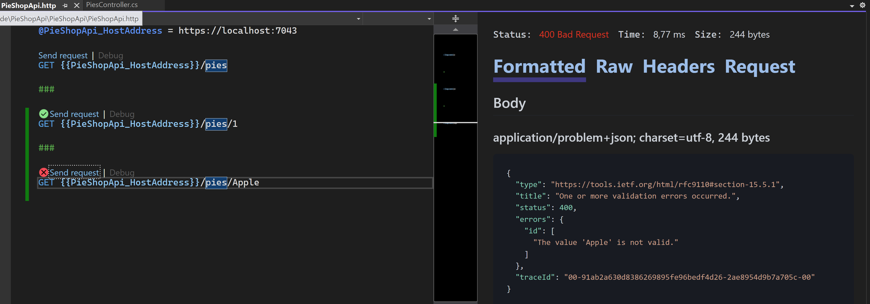
As expected, we get this error, because “Apple” can not be bound to an integer value.
However, as we’re requesting an URI that does not exist, we’re better of with a HTTP status code 404-Not Found.
This can easily be implemented with using a Route Constraint in our Route template.
- Adding the a route constraint, that allows only int values for the id
[HttpGet]
[Route("{id:int}")]
public Pie GetPie(int id)
{
return PieStore.GetById(id);
}
- Launch the application again (F5) and test the effect
  - https://localhost:7043/pies/1 Still works!
  - https://localhost:7043/pies/Apple Return a 404 Not Found error
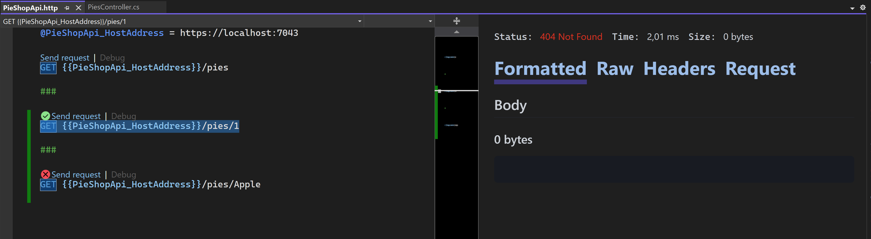

Add the SearchPie method
In this part, we’ll add another method that get’s a pie based on its name.
We’ve already implemented the method in our PieStore: “GetByPartialName(string name)”.
Instead of passing the name as a route value, we’ll extend our route with “search” and use a query string parameter called “name”. Doing this, makes the URI very descriptive for our consumers.
e.g. https://localhost:7043/pies/search?name=Apple
Steps:
- Add a the SearchPie method with route template “search”.
[HttpGet]
[Route("search")]
public Pie SearchPie(string name)
{
return PieStore.GetByPartialName(name);
}
- Add another test to our PieShopApi.http file
GET {{PieShopApi_HostAddress}}/pies/search?name=Apple
- Launch the application (F5) and test
